**Shell commands and java programing**

* Before learning HDFS programming practice, we need to start Hadoop.

By using command **start-all.sh.**

* We can enter the following commands in the terminal to see which commands are supported by fs:

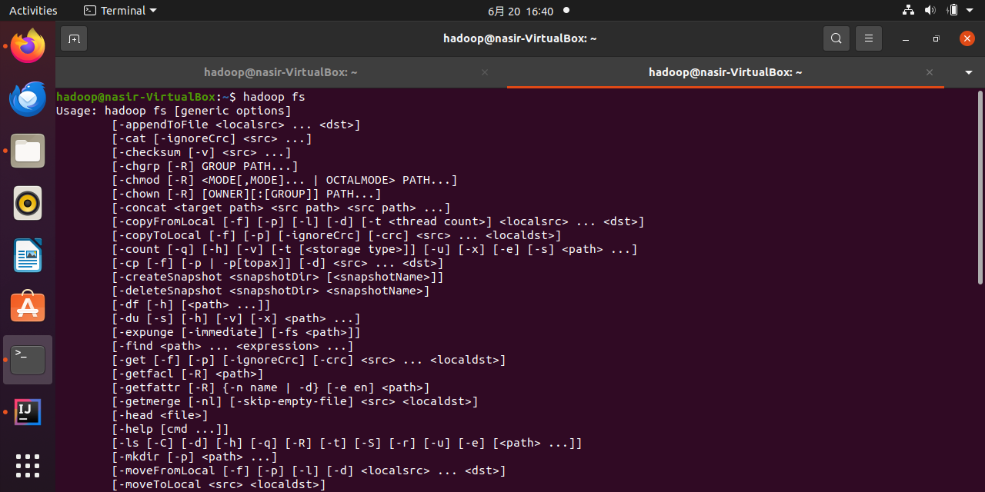

* Enter the following command in the terminal, you can view the function of a specific command.
* For example: we see how to use the *put* command, you can enter the following command.

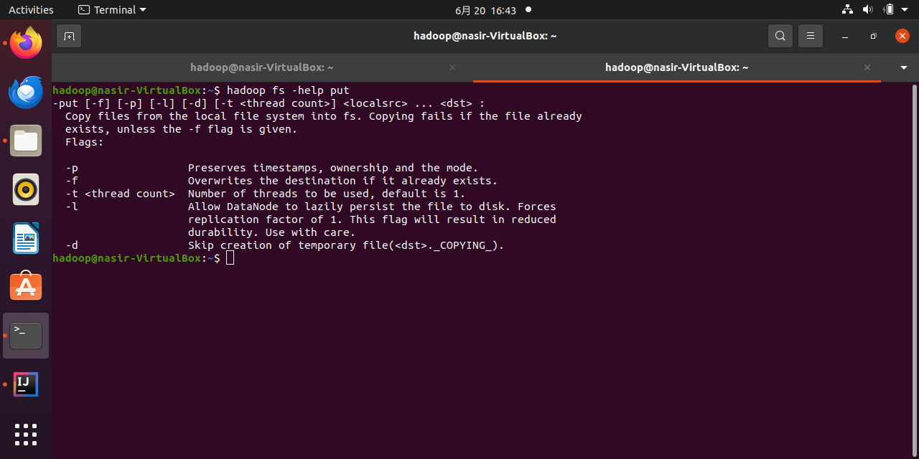

* the following command to display the contents of the user directory corresponding to the current user hadoop in HDFS:

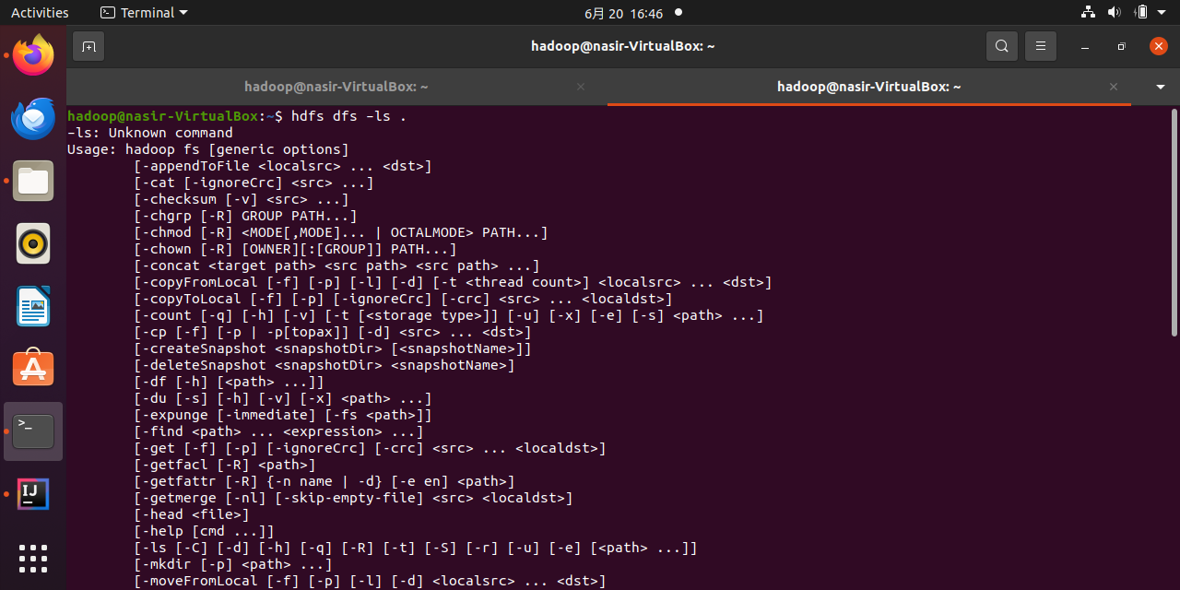

* Open the Firefox browser that comes with Linux, click this link HDFS web interface(e.g. http://localhost:9870), you can see the HDFS web management interface.

